**FINAL PROJECT PROPOSAL**

**Introduction**

We want to make a two player puzzle game. The players are controlling two different characters that will have some kind of coordinating mechanism. By this, we mean that the characters will complement each other in some way. An example of this could be: one player is an ice character and the other is a fire character. The puzzle is designed in such a way that the two characters have to strategize around their abilities to solve it. Example clarifying this idea:

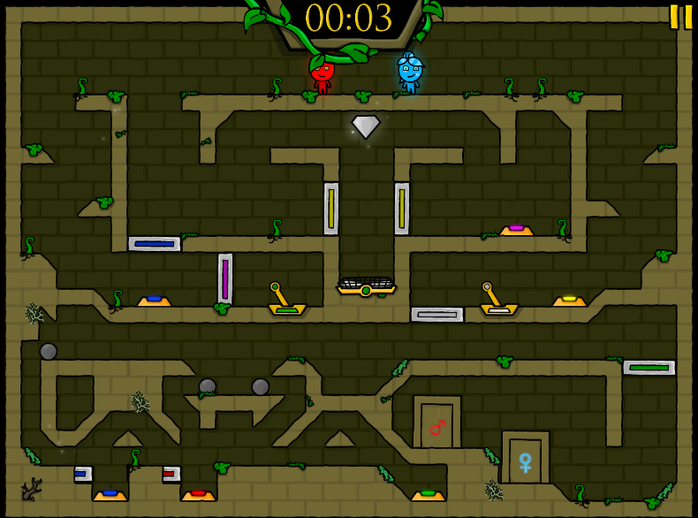

Fire Boy is the only one who can activate red switches. Ice Girl is the only one who can activate blue switches. Another example is that Ice Girl has the ability to climb “slopes” while Fire Boy doesn’t. Like so, this applies to different objects in the game. The two players have to use their character’s different properties and abilities to coordinate and solve the puzzle.

To clarify, our game is not going to have the same characters (ice boy and fire girl) or the same game mechanics, it’ll just be similar in nature to that puzzle-type game where the two players have to coordinate around their different abilities to complete the level.

**Rough game implementation:**

- one horizontal level using x_shift. (not the vertical level as shown in the screenshot)

- one player uses the WASD keys to control the movement of their character and the other uses arrow keys to control the movement of theirs.

- using stripe animations for both characters and the objects in the game environment

**Which group member is doing what task:**

Both work on the overall structure of the code (how to structure classes, methods and so on) and both work on debugging.

- Matija : stripe animations and background environment  
- Ayyub : puzzle structure, keyboard and mouse interaction